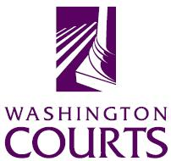 administrative office of the courts

December 16, 2019

TO: Judicial and Legal Communities

FROM: Stephanie Happold, Principal Legal Analyst

SUBJECT: DECEMBER 2019 SUMMARY OF CHANGES TO THE PETITION FOR AN EXTREME RISK PROTECTION ORDER FORM

The Washington Pattern Forms Committee changed the Petition for an Extreme Risk Protection Order, XR 101, based upon the JIS Codes Committee changing the docket/event code from the generic “PT” to “PTXR.” Also, RCW 7.94.150(1) requires the Washington State Administrative Office of the Courts to develop standard petition and order forms for the extreme risk protection order process; therefore, the word “Mandatory” was added to the footer.

